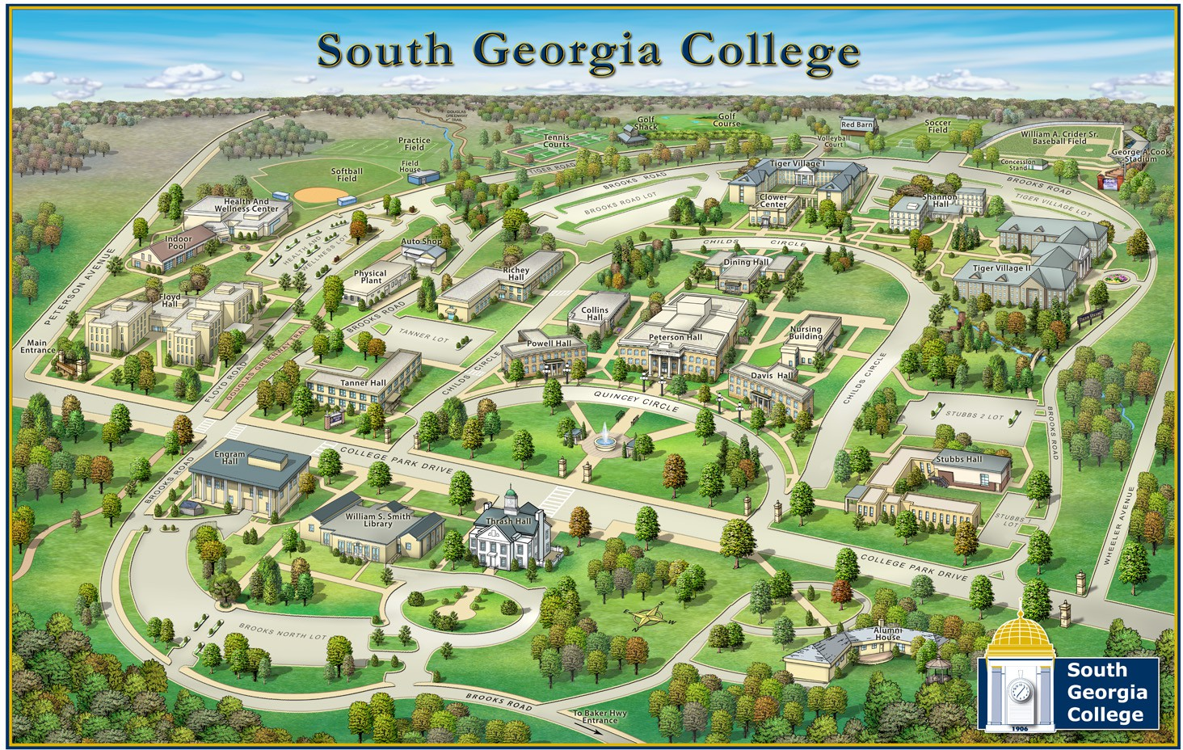
Parking
Parking
Parking

Parking

Parking

One Way
Do Not Enter

Parking

Parking

Parking
Student Parking
Employee Parking
SGSC
Douglas Campus

